USER MANUAL

Managing the Base Tables:

All base tables have a form for entering and removing rows from the database. To add or update a row, simply edit the table by clicking on the cell that you with to edit and entering the desired value. Once you have finished entering your data, simply click save to commit those changes to the database. To remove a row, just highlight the row, or a cell in the row that you wish to delete, and click the delete button, after that click the save button to commit that delete.

Company:

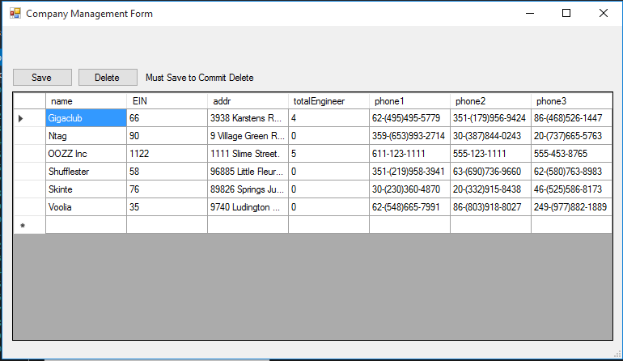

Engineer:

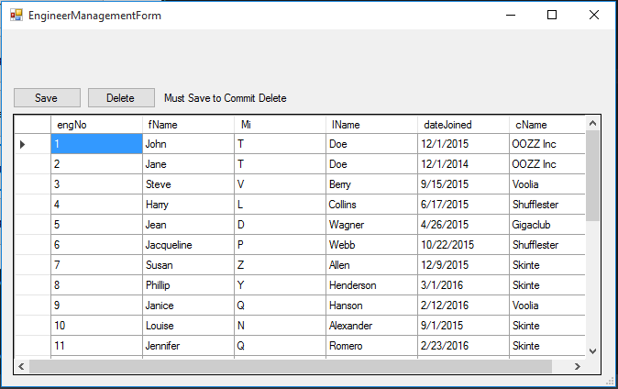

Equipment:

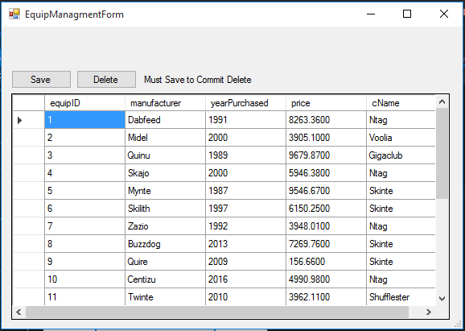

Faults:

There are two special kinds of faults that can be registered in this database: Electrical and Mechanical. These faults will require that you provide an ID for the part needed to repair the fault. Otherwise all faults require a unique ID, description, and the ID for the broken equipment in question.

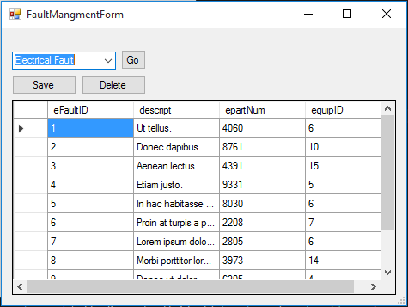

Submitting Repairs:

To submit a repair, you will use the Repair Management form accessed by clicking the button labeled Manage Repairs. From there you can select the engineer from the top left drop list who has made the repair. Now you can see all the repairs that your currently selected engineer has made, and can click the “Make Repair” button on the top left to open up a repair submission form.

